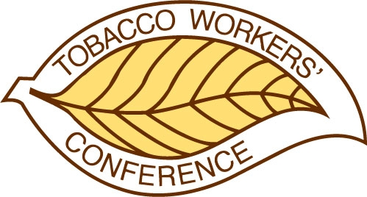
50th TOBACCO WORKERS’ CONFERENCE

NOMINATIONS FOR 25-YEAR CERTIFICATE

Nominees should have been associated with the Tobacco Workers’ Conference for 25 years or more, unless they have previously been recognized by the Tobacco Workers’ Conference. Self-nominations are permissible.

Nominee:

Organization & Title:

Address:

Telephone: Fax:

Length of Service: E-mail address:

Brief Description of Work;

Nominated by:

Address:

Tel: E-mail:

50th TOBACCO WORKERS’ CONFERENCE

DECEASED TOBACCO WORKERS

Please submit the name of a person who has died since the 49th TWC, if you think it would be appropriate for the 50th TWC to extend condolences to their family.

Name of Deceased:

Organization & Title:

Name & Address of Family:

Nominator:

Address:

Telephone: E-mail :

Reply by December 3, 2021 to:
Matthew Vann
North Carolina State University
matthew_vann@ncsu.edu

