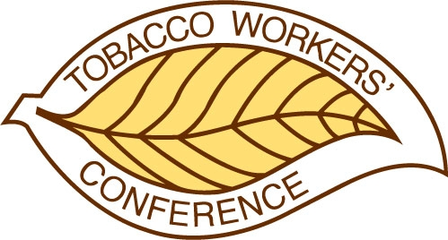
50th TOBACCO WORKERS’ CONFERENCE
COMMITTEE MEETING ROOM REQUEST

Name of Committee or Group:

Name of Chairperson or Organizer:

Chairperson’s e-mail address:

Preferred Time:

Preferred Date (if other than Monday, January 24, 2022):

Length of Time to be Allocated:

Expected Number of Attendees:

Please send this completed form by October 20, 2021 to:

Carrie Zaklikowski
50th Tobacco Workers Conference
Creekwood Event Services
carrie@creekwoodes-us.com

